**OPPOSITION Nо B 3 204 828**

**Louis Vuitton Malletier**, 2 rue du Pont-Neuf, 75001 Paris, France (opponent), represented by **T Mark Conseils**, 9 avenue Percier, 75008 Paris, France (professional representative)

a g a i n s t

**Seyed Omid Dehghan**, Aletta Jacobsstraat 77, 1963CB Heemskerk, Netherlands (applicant).

On 16/09/2024, the Opposition Division takes the following

**DECISION:**

**1.** Opposition No B 3 204 828 is upheld for all the contested goods and services.

**2.** European Union trade mark application No 18 896 466 is rejected in its entirety.

**3.** The applicant bears the costs, fixed at EUR 620.

**REASONS**

On 11/10/2023, the opponent filed an opposition against all the goods and services of European Union trade mark application No 18 896 466 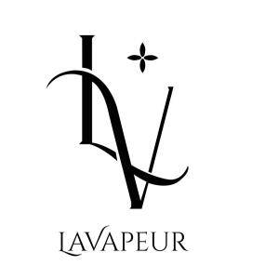 (figurative mark). The opposition is based on the following earlier marks:

1. European Union trade mark registration No 15 628 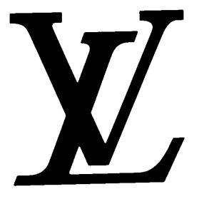 (figurative mark) (earlier mark 1);

2. French trade mark registration No 4 855 397 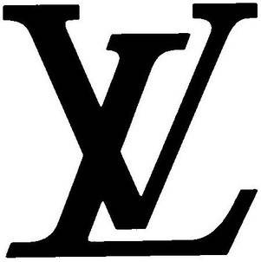 (figurative mark) (earlier mark 2);

3. international trade mark registration designating the European Union No 1 127 687 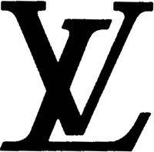 (figurative mark) (earlier mark 3);

4. French trade mark registration No 4 829 389  (figurative mark) (earlier mark 4).

The opponent invoked Article 8(1)(b) EUTMR in relation to earlier marks 2-4 and Article 8(5) EUTMR in relation to earlier mark 1.

**REPUTATION – ARTICLE 8(5) EUTMR**

The opponent invoked Article 8(5) EUTMR in relation to, inter alia, earlier European Union trade mark registration No 15 628 (earlier mark 1). For reasons of procedural economy, the Opposition Division will first examine the opposition in relation to this earlier mark.

According to Article 8(5) EUTMR, upon opposition by the proprietor of a registered earlier trade mark within the meaning of Article 8(2) EUTMR, the contested trade mark will not be registered where it is identical with, or similar to, an earlier trade mark, irrespective of whether the goods or services for which it is applied are identical with, similar to or not similar to those for which the earlier trade mark is registered, where, in the case of an earlier European Union trade mark, the trade mark has a reputation in the Union or, in the case of an earlier national trade mark, the trade mark has a reputation in the Member State concerned and where the use without due cause of the contested trade mark would take unfair advantage of, or be detrimental to, the distinctive character or the repute of the earlier trade mark.

Therefore, the grounds for refusal of Article 8(5) EUTMR are only applicable when the following conditions are met.

• The signs must be either identical or similar.

• The opponent’s trade mark must have a reputation. The reputation must also be prior to the filing of the contested trade mark; it must exist in the territory concerned and for the goods and/or services on which the opposition is based.

• Risk of injury: use of the contested trade mark would take unfair advantage of, or be detrimental to, the distinctive character or repute of the earlier trade mark.

The abovementioned requirements are cumulative and, therefore, the absence of any one of them will lead to the rejection of the opposition under Article 8(5) EUTMR (16/12/2010, T‑357/08, BOTOCYL / BOTOX, EU:T:2010:529, § 41; 16/12/2010, T‑345/08, BOTOLIST / BOTOX, EU:T:2010:529, § 41). However, the fulfilment of all the abovementioned conditions may not be sufficient. The opposition may still fail if the applicant establishes due cause for the use of the contested trade mark.

In the present case, the applicant did not claim to have due cause for using the contested mark. Therefore, in the absence of any indications to the contrary, it must be assumed that no due cause exists.

**a) Reputation of the earlier trade mark**

Reputation implies a knowledge threshold that is reached only when the earlier mark is known by a significant part of the relevant public for the goods or services it covers. The relevant public is, depending on the goods or services marketed, either the public at large or a more specialised public.

In the present case, the contested trade mark was filed on 04/07/2023. Therefore, the opponent was required to prove that the trade mark on which the opposition is based had acquired a reputation prior to that date. In principle, it is sufficient that the opponent show that its mark already had a reputation on that date. While it follows from the wording of Article 8(5) EUTMR that the conditions for its application also need to be present at the time of taking the decision, and therefore the reputation of the earlier mark must subsist until the decision on the opposition is taken, any subsequent loss of reputation is for the applicant to claim and prove.

The evidence must also show that the reputation was acquired for the goods for which the opponent has claimed reputation, namely:

Class 18: *Goods made of leather or of imitations of leather not included in other classes in particular boxes of leather or of leatherboard, envelopes of leather or of imitation of leather; trunks, valises, travelling bags, travelling sets, garment bags for travel, vanity-cases, chests, bags, rucksacks, handbags, beach bags, shopping bags, shoulder bags, suitcases, attaché-cases, briefcases, satchels, pouches, fine leather goods in particular pocket wallets, coin purses not of precious metal, purses, key-holders, card holders; umbrellas, parasols, sunshades, canes, walking-stick seats.*

Class 25: *Clothing, underwear and other clothing articles, in particular sweaters, shirts, dress bodies, corsets, suits, waistcoats, waterproofs clothing, skirts, coats, pullovers, trousers, dresses, clothing jackets, shawls, stoles, sashes for wear, scarves, neck ties, ties, pocket handkerchiefs for wear, braces, clothing gloves, clothing belts, stocking, tights, socks, bathing suits, bath robes; footwear; headgear for wear.*

The opposition is directed against the following goods and services:

Class 34: *Absorbent paper for tobacco; absorbent paper for tobacco pipes; cigarette paper; cigarette papers; cigarette rolling papers; electronic cigarette atomizers; electronic cigarette cartomizers; vaporizers for smoking purposes; smokeless cigarette vaporizer pipes; hookah tobacco; electronic hookahs; electronic cigarette liquid [e-liquid] comprised of vegetable glycerin; personal vaporisers and electronic cigarettes, and flavourings and solutions therefor; cigars for use as an alternative to tobacco cigarettes; oral vaporizers for smokers; hookahs; ashtrays; ashtrays for smokers; ashtrays of precious metal; ashtrays for smokers made of non-precious metals; ashtrays for smokers made of precious metals; ashtrays incorporating match lighters; ashtrays, not of precious metal; cigarettes; tips of yellow amber for cigar and cigarette holders; yellow amber (tips of -) for cigar and cigarette holders; tips (cigarette -); cigarette tips; filter tips for cigarettes; tipping paper for cigarettes; filter tips; bags for pipes; pipe pouches; devices for heating tobacco for the purpose of inhalation; filter-tipped cigarettes; cigarette tobacco; electric cigarettes [electronic cigarettes]; electronic cigarettes; mouthpieces for cigarettes; menthol cigarettes; cigarette lighters; cigarettes, cigars, cigarillos and other ready-for-use smoking articles; cartridges for electronic cigarettes; cigarette packets; liquid for electronic cigarettes; liquids for electronic cigarettes; electronic cigarette cleaners; holders for electronic cigarettes; replaceable cartridges for electronic cigarettes; electronic cigarettes for use as an alternative to traditional cigarettes; liquid nicotine solutions for electronic cigarettes; electronic rechargeable cigarette cases; electronic cigarette cases; cases for electronic cigarettes; electronic cigarette liquid [e-liquid] comprised of propylene glycol; smoking pipe cleaners; electronic cigars; containers for cigars; humidifiers for cigars; cigar humidifiers; cigar lighters; small cigars; cigar cutters; cutters (cigar -); cigar clippers; cigar holders; cigar pouches; cigar filters; cigar cases; cases (cigar -); humidors for cigars of precious metal; cigars; pipes; pipe cleaners for tobacco pipes; pipe racks for tobacco pipes; smoking pipes; pipe tobacco; tobacco pipes; pipes (tobacco -).*

Class 35: *Business assistance; business assistance, management and administrative services; advertising, marketing and promotional services; retail services relating to fragrancing preparations; retail services in relation to articles for use with tobacco; wholesale services in relation to articles for use with tobacco.*

In order to determine the mark’s level of reputation, all the relevant facts of the case must be taken into consideration, including, in particular, the market share held by the trade mark, the intensity, geographical extent and duration of its use, and the size of the investment made by the undertaking in promoting it.

On 01/03/2024 and 03/03/2024, the opponent submitted the following evidence.

• **Annex 1**:

o Printouts from the website www.wikipedia.org (print date 19/04/2023) concerning the history of the opponent’s company, its brand and intellectual property, and its products, as well as its advertising campaigns and special collaborations with prominent artists and designers. It also states that the opponent ‘is a French luxury fashion house and company founded in 1854 by Louis Vuitton. The label’s LV monogram appears on most of its products, ranging from luxury bags and leather goods to ready-to-wear, shoes, perfumes, watches, jewelry, accessories, sunglasses and books. Louis Vuitton is one of the world’s leading international fashion houses.’ It further mentions that ‘for six consecutive years (2006–2012), Louis Vuitton was named the world’s most valuable luxury brand.’

o A copy of a document entitled ‘Louis Vuitton Savoir-Faire, History: 150 years of Louis Vuitton’, prepared by the Louis Vuitton Corporate Press Department, and a copy of a document entitled ‘The creation of the Monogram canvas: a founder element of modern luxury’, containing information about the origin and history of Louis Vuitton’s ‘Monogram canvas’, involving the initials of the company’s founder.

o A list of Louis Vuitton’s 517 stores worldwide, updated on 15/10/2022, and a printout from the opponent’s website (print date 20/07/2023) showing Louis Vuitton’s current stores in, inter alia, various Member States of the European Union.

o A printout from an online article of 23/08/2013 entitled ‘Amazing Louis Vuitton Stores that you must visit’, listing and depicting the stores in, inter alia, Paris (Champs-Élysées) and Venice.

o A printout from an online article entitled ‘Louis Vuitton: leather goods, a prestigious French know-how’ published on the website https://www.francealumni.fr (France Alumni [Colombia]) (print date 10/05/2022). The article reports, inter alia, that the opponent ‘remains a brand associated with the prestigious image of French luxury throughout the world’ and that ‘the reputation of this French know-how is international’.

o A printout from an online article entitled ‘The Louis Vuitton trunks that take 150 hours to make’ published on the website https://www.wsj.com (WSJ magazine) and dated 23/05/2017. The article is about the opponent’s atelier in the commune of Asnières-sur-Seine and contains short interviews with some employees working in the atelier.

o A printout from an online article about the opponent published on the website https://www.forbes.com (print date 19/04/2023). The article states that the opponent is ‘the world’s most valuable luxury brand and is a division of LVMH.’ whose products include leather goods, handbags, trunks, shoes, watches, jewellery, and accessories, most of them adorned with the LV monogram. According to the article, LV monogram is ‘one of the most profitable brands in the world with profit margins north of 30%.’.

o A printout from an online article entitled ‘Inside the largest Louis Vuitton men’s store in the United States’ published on the website https://ww.fashionnetwork.com and dated 18/07/2022. The article concerns the newly opened Louis Vuitton men’s store located on Rodeo Drive in the Beverly Hills neighbourhood of Los Angeles.

o A printout from an online article entitled ‘Lionel Messi Stars Solo in Latest Louis Vuitton Campaign’ published on the website https://www.vanityteen.com (print date 19/04/2023). The article contains the opponent’s advertising campaign showing a picture of Messi leaning on a suitcase with the LV monogram. It also contains a post published on Instagram concerning this campaign.

o A printout from an online article entitled ‘Louis Vuitton leads and Saint Laurent returns to the top five in the Vogue Business Index: Winter 2022/23 edition’ published on the website https://www.voguebusiness.com (Vogue Magazine) and dated 26/01/2023. The opponent is mentioned in 1st place in the ‘Vogue Business Index’ ranking for winter 2022/2023.

o A printout from an online article entitled ‘Louis Vuitton ups its bet on the Spanish market, opens third store in Madrid’, published on the website https://ww.fashionnetwork.com and dated 26/11/2022. The article concerns the newly opened Louis Vuitton boutique in the ‘Galería Canalejas’ shopping centre in Madrid.

o A printout from an online article entitled ‘Louis Vuitton x Yayoi Kusama: A new arty collab full of pep’ published on the website https://magazine.luxus-plus.com and dated 17/01/2023. The article concerns the second collaboration between the opponent and the Japanese artist Yayoi Kusama on a special ‘polka dots’ collection.

o A printout from an online article entitled ‘Milan Design Fair: Hermès and Louis Vuitton focus on ever more luxurious design’ published on the website https://ww.fashionnetwork.com and dated 19/04/2023. The article mentions, inter alia, that during Milan Design Week the opponent presented sixty pieces of furniture, as well as the ‘Objets Nomades’ collection of travel-inspired items it launched in 2012 in collaboration with top designers. The opponent’s ‘iconic’ travel trunk was also the focus of a special project called ‘Cabinet of Curiosities’; in addition, the opponent exhibited a new nomadic architecture, a light, organic metal structure.

o A printout from an online article entitled ‘Louis Vuitton – Success Factors Of The Top Luxury Brand’, published on the website https://thebrandhopper.com and dated 25/12/2020. According to the article, the opponent is ‘a French fashion house founded in 1854 by the famous designer, Louis Vuitton. The founder’s initials are on most of the brand’s products from clothing, footwear, watches, leather goods, jewelry, accessories, and sunglasses.’ The article claims ‘Louis Vuitton’ to be ‘one of the world’s largest fashion houses’. It further states that ‘the Louis Vuitton brand and the LV monogram are one of the most valuable trade marks in the world’ and that ‘LV is a premium luxury brand’ focusing its high-priced products only on the luxury market. The opponent’s history, marketing strategies and collaboration with famous artists are also referred to in the article.

• **Annex 2**:

o copies of excerpts from *BRANDZ Top 100 Most Powerful Brands* for 2006-2008 and *BRANDZ Top 100 Most Valuable Global Brands* for 2009-2012. The evidence shows the rankings for the ‘Louis Vuitton’ and/or  brands respectively.

The *BRANDZ Top 100 Most Valuable Global Brands* *2009* study ranks Louis Vuitton as brand no 1 among luxury brands, with a brand value of USD 19.4 billion, and refers to it as ‘the most ubiquitous luxury brand’. It further states that ‘after many years of high growth, with exciting and avant-garde designs and advertising, in 2008 Louis Vuitton went back to its heritage with the launch of the Journey campaign, featuring celebrities, such as Keith Richards and Sean Connery. The idea of the campaign is a celebration of Louis Vuitton’s origins: travel and discovery, but also an invitation for consumers to live their lives as a journey. This was a masterstroke in the current times. People are looking for brands they can trust, that have stood the test of time and that they perceive to provide value. Louis Vuitton’s classic quality and timeless style play straight into this trend’.

According to the *BRANDZ Top 100 Most Valuable Global Brands* *2010* study, ‘Louis Vuitton, the most valuable luxury brand over the last five years, continued to position itself as timeless and authentic. Rather than compromising its brand value during the recession, it increased prices, invested in creativity and heightened the focus on quality’.

The *BRANDZ Top 100 Most Valuable Global Brands* *2011* study ranks  as brand no 26, with a brand value of USD 24 312 million. It further mentions that Louis Vuitton ‘remained the highest-valued luxury brand and increased in value by 23 percent’.

The *BRANDZ Top 100 Most Valuable Global Brands* *2012* study places  as brand no 21, with a brand value of USD 25 920 million. It further states that Louis Vuitton is still the no 1 luxury brand, and no 2 among the Top 10 continental European brands.

o Copies of excerpts from *Eurobrand* for 2009-2011, showing the ranking of brands by the European Brand Institute - Vienna. The sign 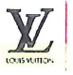appears in 4th place in 2009 and in 3rd place in 2010.

o Copies of excerpts from *Global Top 100 brand corporations* for 2013-2022. In 2018 and 2019, LVMH Group was Europe’s most valuable brand corporation and was ranked 6th worldwide. In 2020, it ranked 5th, and the year after 6th worldwide, while it remained Europe’s most valuable brand corporation. In 2022, LVMH again took 5th place worldwide, and 1st place in Europe and France.

o Copies of *Interbrand* *Best Global Brands* showing the rankings of the ‘Louis Vuitton’ and/or  brands in the luxury sector for 2008, 2011, and 2013-2022. It can be seen that ‘Louis Vuitton’ ranked 17th in 2020 with a brand value of USD 31 720 million, 13th in 2021 with a brand value of USD 36 766 million, and 14th in 2022 with a brand value of USD 44 508 million.

Furthermore, according to the 2011 report, ‘Louis Vuitton reports 19 percent growth in revenue over the past year and still remains the strongest luxury brand in the world. For many the brand depicts attainable luxury and is a highly desirable symbol of success’.

o A printout from an online article entitled ‘Louis Vuitton ranks as most valuable luxury company in Interbrand’s 2021 Top Global Brands’ published on the website www.fashionunited.com and dated 02/11/2021. The article states, inter alia, that ‘The French luxury maison ranks at number 13 and is the only fashion company featured in the top 20.’

o The annual *Europe 500* report on the most valuable and strongest European brands from June 2021. It shows that the  brand ranked 24th in the ‘Apparel’ sector.

o A printout from the website https://www.rankingthebrands.com containing the *BRANDZ Top 100 Most Valuable Global Brands* ranking for 2022 by Kantar, where ‘Louis Vuitton’ is ranked 10th.

o A printout from an online article entitled ‘At $26 billion, Louis Vuitton is the world’s most valuable luxury brand’, published on the website www.businessinsider.com and dated 24/05/2012. The article states: ‘The French fashion house has been valued at £16.5 billion ($25.9 billion), making it the most valuable luxury fashion brand. Louis Vuitton has been named the most valuable luxury brand in the world for the seventh year running’.

o A printout from an online article entitled ‘Louis Vuitton remains the most powerful French brand’, published on the website www.mieuxvivre-votreargent.fr and dated 27/01/2020. The article names the leather goods maker Louis Vuitton as the ‘flagship brand of luxury giant LVMH’, leading BrandZ Top 50 France by Kantar with a brand value of USD 53.4 billion.

o A printout from an online article entitled ‘Chanel? Dior? In your opinion, what is the most searched brand on the Internet in 2020?’, published on the website https://www.grazia.fr (print date 11/05/2022). According to the article, Louis Vuitton was the most searched and therefore most popular luxury brand on Google in 2020, with 700 000 monthly queries on average on the search engine.

• **Annex 3**:

o A document showing revenues for LVMH Group for Q3 2016, Q1 and Q3 2017, Q3 2018, Q1 and Q3 2019, and Q3 2020. For the business group ‘Fashion and leather goods’, which includes Louis Vuitton, there was growth between 2016 and 2020, as seen in the charts below:

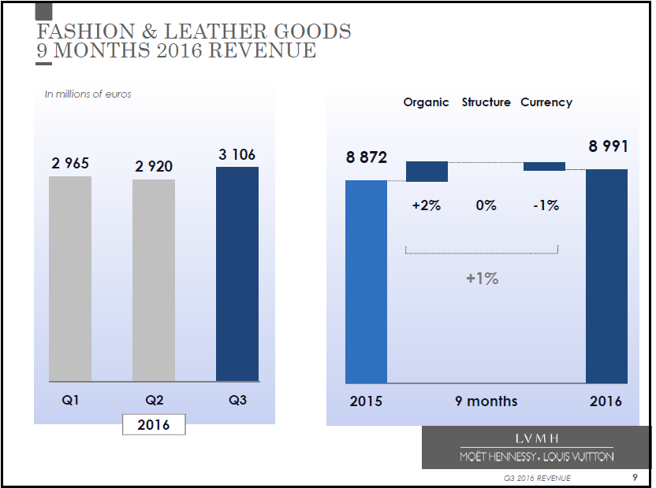

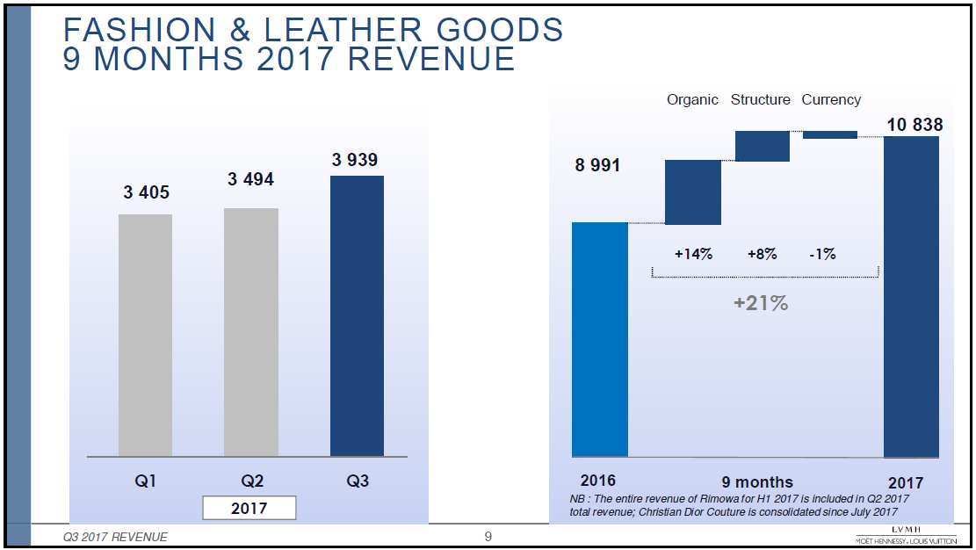

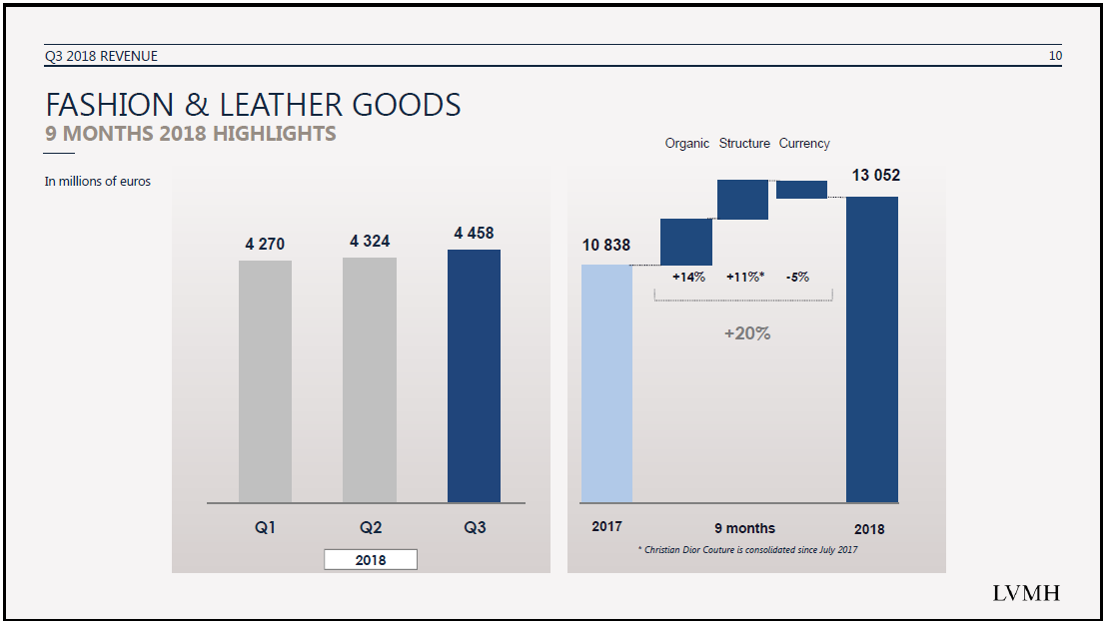

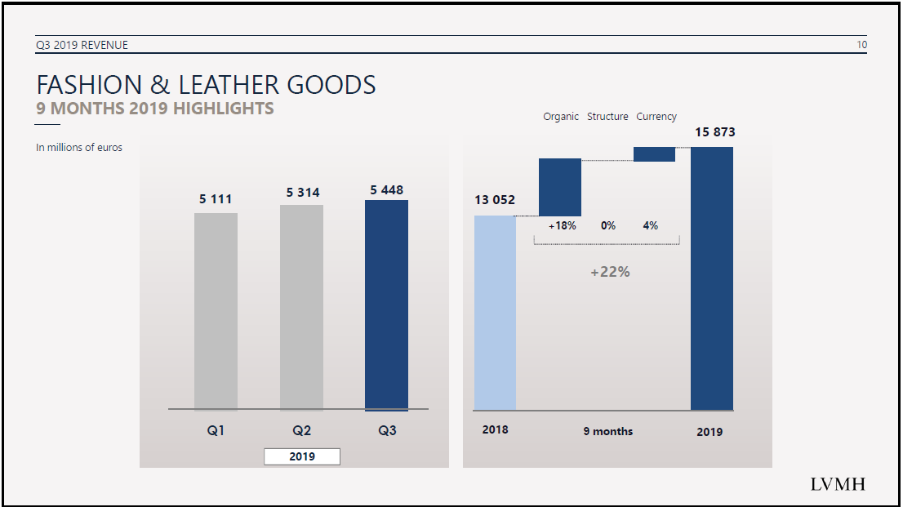

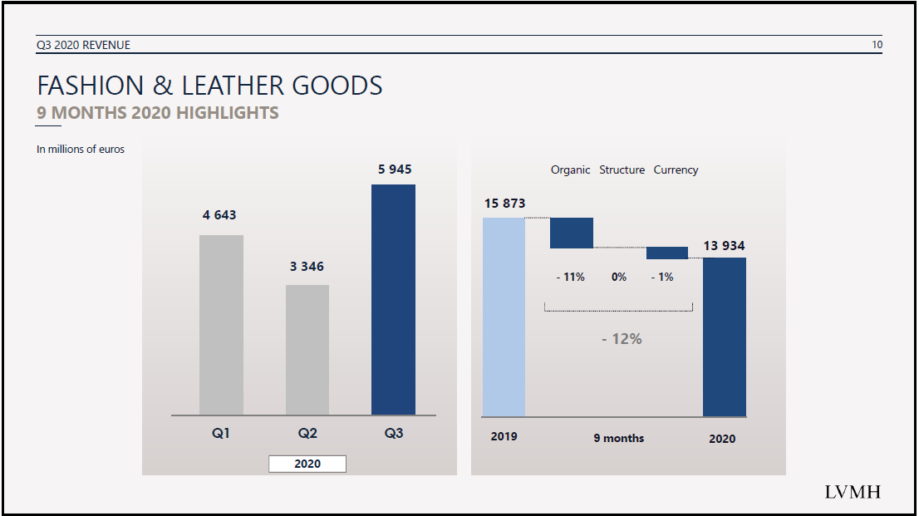

o The LVMH 2021 and 2022 annual reports *Passionate about creativity*,showing, inter alia, that in 2011 21 % of the revenue came from Europe (including France) and 48 % of the total revenue was generated by the business group ‘Fashion & Leather Goods’, while in 2022 24 % of the revenue came from Europe (including France) and 49 % of the total revenue was generated by this business group.

o A document entitled ‘2023: New record year for LVMH’, reporting that ‘LVMH Moët Hennessy Louis Vuitton, the world’s leading luxury goods group, recorded revenue of EUR 86.2 billion in 2023, equating to organic growth of 13% with respect to 2022.’ It also mentions the group’s ‘major economic and social impact in France and around the world’. The document is dated 25/01/2024 and contains the following table with revenue details:

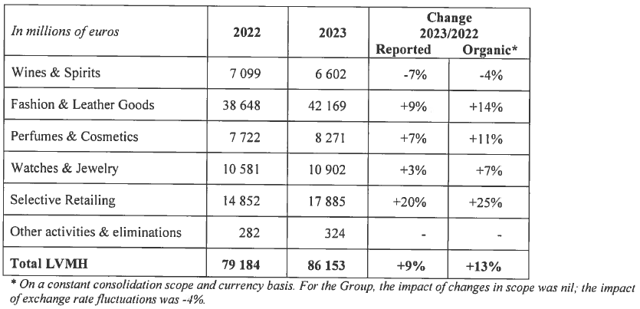

• **Annexes 4-6**: printouts from Louis Vuitton’s Instagram, Facebook and Twitter accounts showing publicity posts and advertising campaigns, dated between 2014 and 2024, promoting the opponent’s goods, mainly handbags, purses and various items of clothing and footwear. Most of the goods are in the Louis Vuitton ‘Monogram canvas’ and/or bear the sign  (or its slight variations). It can be inferred from the documents that the opponent had more than 55 million followers on Instagram (by 01/03/2024), 25 million followers on Facebook (by 01/03/2024) and almost 10 million subscribers on Twitter (by 29/04/2023).

• **Annexes 7-8**:

o Copies of pictures featuring Louis Vuitton’s advertising campaigns in 2006-2011. Some of the pictures are accompanied by press releases; one press release mentions Madonna as the face of Louis Vuitton’s Spring/Summer 2009 advertising campaign. Various handbags, clothing articles (mainly for women) and fashion accessories are shown in the pictures, bearing the sign  (or its slight variations) and other motifs of the Louis Vuitton ‘Monogram canvas’.

o Copies of pictures of Louis Vuitton’s advertising campaigns carried out in 2007-2010 and starring celebrities and famous personalities (e.g. Catherine Deneuve, Mikhail Gorbachev, Andre Agassi & Steffi Graf, Sir Sean Connery, Keith Richards, Sofia & Francis Ford Coppola, Pele, Diego Maradona, and Zinedine Zidane). Some of them are accompanied by corresponding press releases issued by the Louis Vuitton Communication Department. Various trunks, travelling bags and handbags in the Louis Vuitton ‘Monogram canvas’ are displayed in the pictures.

o Copies of excerpts from Louis Vuitton’s catalogues dated 2005-2014, with pictures of goods such as trunks, luggage, suitcases, bags, clutches, travel accessories, backpacks, briefcases, and small leather goods including travel organisers, wallets, credit card holders, purses, key holders, pouches and cases (e.g. spectacle cases, cigarette cases, and mobile phone cases), as well as watches. The catalogues also depict footwear, headgear and clothing, such as coats, knitwear, pants, scarfs, gloves, boots, dresses, jackets, sweaters, skirts, blouses, cardigans, sandals, pumps, stoles, shirts, flip-flops, shorts, ballerinas, hats, caps, swimwear, belts, shoes, ties, sneakers, suits, pocket squares, parkas, raincoats, vests and socks. The clothing in the pictures is mainly for women. Most of the goods are in the Louis Vuitton ‘Monogram canvas’ and/or bear the sign  (or its slight variations). In some of the catalogues the sign  is shown independently, either at the bottom of the page or on pictures of goods in the catalogue concerned.

o A clipping from Louis Vuitton’s advertising campaigns carried out in 2008-2020, mainly depicting handbags and other carrying bags with the Louis Vuitton ‘Monogram canvas’ and/or the sign  (or its slight variations).

o Excerpts from several LVMH magazines (or, as the opponent states, promotional books) dated between September 2015 and September 2022 showing the sign  (or its slight variations) on some of the goods, such as suitcases, handbags, luggage, trunks, bags, shoes, belts, scarves and wallets.

• **Annex 9**: copies of excerpts or press cuttings from various Italian (e.g. *Vogue*, *Amica*, *Elle*, *GQ*), French (e.g. *Le Figaro*, *Air France Magazine*, *Vogue*, *Paris Capitale*, *Gala*, *Elle*, *Madame Figaro*, *Les Echos*, *Glamour*), Spanish (e.g. *Elle*, *Vogue*, *Telva*, *Cuore Stilo*, *Hola*, *Cosmopolitan*, *Marie Claire*, *El País*, *La Vanguardia*, *Harper’s bazaar*, *Expansión*, *El Mundo*, *InStyle*, *Glamour*), German (*Elle*, *Jolie*, *Vanity Fair*, *Madame*, *Amica*, *Gala*), Austrian (*Flair*), Belgian (*Glam-it*, *Owl city*, *Elle*), Czech (*Flair*), Greek (*Forbes*), Hungarian (*Sport&Style*), Finnish (*Arvopaperi*), Dutch (*Elle*, *Avantgarde*, *Feeling*, *Gala*, *Hitkrant*) and Swedish (*Elle*, *Rodeo Magazine*) magazines and newspapers. The materials are mainly dated between 2006 and 2010 (some of the Spanish magazines are also dated between 2017-2020) and consist of advertisements related to the opponent’s goods. The sign  (or its slight variations) is shown on various goods, such as travelling bags, bags, handbags, shoulder bags, suitcases, pocket wallets, purses, and card holders, as well as on/in relation to some clothing articles, mainly for women (e.g. dresses, scarves, gloves, shawls, raincoats, skirts, and shorts). In some of the documents, it is displayed independently of the ‘Monogram canvas’.

• **Annex 10**: copies of various decisions and judgments confirming the reputation of the opponent’s trade mark.

o A decision of the Spanish trade mark office of 28/04/2022 (along with the English translation of the relevant parts) acknowledging that the mark  enjoys a general reputation, which goes beyond the sector in which it operates (i.e. fashion).

o A decision of the Spanish trade mark office of 26/02/2021 (along with the English translation of the relevant parts) attesting to the reputation of the mark  worldwide in the fashion sector.

o Decisions of the Office’s Opposition Division No B 2 491 762 of 11/11/2021, No B 2 659 830 of 11/11/2021, No B 2 704 651 of 11/11/2021 and No B 2 707 407 of 11/11/2021, in which the earlier mark  (earlier mark 1 in the present case) was found to have a reputation in the European Union.

o A decision of the French trade mark office of 09/02/2021 (along with the English translation of the relevant parts), according to which a significant part of the relevant public is familiar with the mark  in the leather goods sector.

o A decision of 26/01/2021 of the Cour d’Appel de Paris, France (along with the English translation of the relevant parts), confirming the findings of first-instance judges on the reputation of the earlier mark  (earlier mark 1 in the present case).

o Decisions of the Office’s Fifth Board of Appeal of 03/11/2020, R 582/2019‑5, LV POWER ENERGY DRINK (fig.) / LV (fig.), and of 03/11/2020, R 583/2019‑5, LV BET ZAKŁADY BUKMACHERSKIE (fig.) / LV (fig.), stating that the earlier mark’s combination of the stylised letters ‘LV’ (earlier mark 1 in the present case) enjoys a strong reputation and as a result has a strong distinctive character.

o A decision of the Office’s Opposition Division No B 3 065 608 of 16/08/2019 establishing the reputation of the earlier mark  (earlier mark 1 in the present case) in the European Union.

o A decision of the Spanish trade mark office of 01/08/2019 (along with the English translation of the relevant parts) upholding the opposition based on the earlier mark  (earlier mark 1 in the present case), inter alia, due to the undue advantage of the notoriety and renowned character of the mark.

o A decision of 08/03/2019 of the Tribunal de Grande Instance de Paris, France (along with the English translation of the relevant parts), in which the reputation of the mark  was established on the basis of the antiquity of the mark, its continuous use since the 19th century, and its recognition by the public.

o A decision of the Spanish trade mark office of 23/05/2018 (along with the English translation of the relevant parts) upholding the opposition based on the earlier mark  (earlier mark 1 in the present case), inter alia, due to the undue advantage of the distinctive character or notoriety of the mark.

o A decision of the Spanish trade mark office of 25/04/2018 (along with the English translation of the relevant parts) upholding the opposition based on the mark , inter alia, due to the undue advantage of the notoriety of the mark.

o A decision of 11/01/2018 of the Tribunal de Milano, Italy, referring to the mark  as a famous mark.

o A decision of the Spanish Trade Mark Office of 04/12/2017 (along with the English translation of the relevant parts) upholding the opposition based on the mark  and considering that undue advantage may be taken of the notoriety of the mark.

o Cancellation decision No 9 393 C of 10/08/2015, which found that the earlier mark  (earlier mark 1 in the present case) enjoyed a high degree of reputation in the European Union and was widely recognised by the relevant public for goods in Class 18, namely goods made of leather or of imitations of leather not included in other classes (in particular trunks, valises, travelling bags, bags, handbags, suitcases, briefcases, pouches pocket wallets, and purses), and for goods in Class 25, namely women’s clothing and other articles of clothing (in particular suits, raincoats, skirts, pullovers, trousers, dresses, shawls, scarves, gloves, and belts) and women’s footwear. The Cancellation Division stated that the earlier mark would be recognised in almost any context and that it reflected a positive image that could positively influence consumer choice regarding the goods or services of other producers or providers.

o A decision of a Belgian Court of 01/02/2013 (along with the English translation of the relevant parts), in which the Court concluded that the mark  is very well-known in the European Union, including the Benelux, and that its reputation extends beyond the target public for the goods and services for which this mark is registered.

o A decision of 19/10/2012 of the Tribunal de Grande Instance de Paris, France (along with the English translation of the relevant parts), which recognised that the earlier mark  (earlier mark 1 in the present case) had a reputation in relation to the goods it covers.

o A decision of 02/03/2012 of the Tribunal de Grande Instance de Paris, France (along with the English translation of the relevant parts) finding that a large proportion of French consumers, who are familiar with LOUIS VUITTON MALLETIER luxury goods, will associate the earlier reputed mark  (earlier mark 1 in the present case) with the contested sign, which would lead to the infringement of the reputed trade mark.

o A decision of the Office’s Board of Appeal of 06/10/2011, R 2124/2010‑1, LN (FIGURATIVE MARK) / LV (FIGURATIVE MARK) et al., confirming the reputation of the earlier mark  (earlier mark 1 in the present case) in the European Union.

o A decision of 28/04/2010 of the Tribunale di Napoli sezione specializzata in materia di proprieta industriale ed intelletuale (District Court of Naples, Italy) (along with the English translation of the relevant parts), which found the ‘Monogram canvas’ and the mark  (earlier mark 1 in the present case) to be absolutely well known and famous.

o A judgment of the Court of Justice of the European Union of 23/03/2010, C‑236/08 - C‑238/08, Google-Louis Vuitton, EU:C:2010:159. Paragraph 28 of this judgment refers to the reputation of the ‘Community trade mark “Vuitton” and of the French national trade marks “Louis Vuitton” and “LV”’.

o A decision of 22/09/2008 of the Court of Copenhagen, Denmark (along with its English translation), ruling on the infringement of the exclusive right to, inter alia, the well-known trade mark ‘Louis Vuitton’.

o A decision of 13/05/2008 of the Tribunale civile di Bologna (Civil Court Bologna, Italy) (along with the English translation of the relevant parts), which states that the ‘Monogram canvas’ and the mark  (earlier mark 1 in the present case) are not only highly known, but also famous.

o A decision of 08/01/2008 of the Tribunal de Grande Instance de Paris, France (along with the English translation of the relevant parts) recognising the reputation of, inter alia, the earlier mark  (earlier mark 1 in the present case) and declaring an infringement of its reputation.

o A decision of 18/12/2007 of the Tribunale civile di Roma (Civil Court Rome, Italy) (along with the English translation of the relevant parts), which states that it is well known that the ‘Monogram canvas’ and the mark  (earlier mark 1 in the present case) have acquired, in particular for leather goods such as bags, suitcases and wallets, a particular reputation in all markets, including the Italian market, and that the goods they distinguish, which have become synonymous with luxury and fashion, are sold at significant prices and are intended for a very narrow category of consumers who are particularly attentive to the their quality and symbolic nature.

o A decision of 14/11/2007 of the Tribunal de Grande Instance de Paris, France (along with the English translation of the relevant parts) recognising the reputation of, inter alia, the earlier mark  (earlier mark 1 in the present case) and declaring an infringement of the rights of its owner.

o Decisions of 13/11/2007, 12/03/2007, 03/02/2007 and 10/10/2006 of the Court of Florence, Italy (along with the English translation of their relevant parts) on the infringement of, inter alia, the earlier mark  (earlier mark 1 in the present case).

o Decisions of the Office’s Opposition Division No B 662 918 of 13/01/2006 and No B 806 143 of 22/06/2006 (along with the English translation of their relevant parts), in which, inter alia, the earlier mark  (earlier mark 1 in the present case) was found to enjoy a (high degree of) reputation in the European Union for fine leather goods and similar products, such as suitcases, bags and belts, and for shoes and clothing.

o A decision of 11/07/2005 of the Court of Rome, Italy (along with the English translation of the relevant parts), which held that Louis Vuitton’s European Union and international trade marks have acquired a particular reputation for bags, suitcases and similar products.

o Decisions of 25/06/2005 and 13/04/2005 of the Court of Florence, Italy (along with the English translation of their relevant parts) on the infringement of, inter alia, the earlier mark  (earlier mark 1 in the present case).

o A decision of the Office’s Board of Appeal of 18/02/2003, R 367/2002‑1, NL (FIGURATIVE MARK) / VL (FIGURATIVE MARK), confirming the reputation of the earlier mark  (earlier mark 1 in the present case) in the European Union for leather goods.

o A decision of 03/10/2002 of a Greek Court (along with the English translation of the relevant parts), upholding the opposition based on, inter alia, the earlier mark  (earlier mark 1 in the present case). According to the Court, the applicant should have known about the existence of this and other trade marks of the opponent Louis Vuitton Malletier, which are famous and well known worldwide and enjoy increased protection. The use of the mark applied for, ‘NV NIKOL’, would harm the reputation of the opponent’s trade marks and would confer, without reasonable cause, an unfair profit from its use and imitation in general.

o A decision of the Office’s Opposition Division No B 340 127 of 26/02/2002, (along with the English translation of its relevant parts), in which the earlier mark  (earlier mark 1 in the present case) was found to enjoy a reputation among the public at large in the European Union at least for leather goods, and more particularly for trunks, suitcases, backpacks, handbags, briefcases, wallets, purses, umbrellas, parasols and walking sticks.

o A decision of 12/05/2000 of a Greek Court (along with the English translation of the relevant parts), confirming the considerable reputation of Louis Vuitton Malletier’s trade marks.

• **Annex 11**: Three brand recognition surveys:

o A survey on the recognition of the Louis Vuitton logo , carried out in January 2021 by Corsearch in collaboration with the survey institute YouGov (an international market survey institute and analytics group and pioneer in online surveys) in the UK, Germany, Italy, Spain, Belgium, the Netherlands, Poland and the Czech Republic. The aim of the survey was to prove the print logo’s association with Louis Vuitton . It was based on a sample of 1 533 respondents in the UK, 1 365 respondents in Germany, 1 036 respondents in Italy, 1 071 respondents in Spain, 990 respondents in Belgium, 1 004 respondents in the Netherlands, 694 respondents in Poland, and 1 060 respondents in the Czech Republic (a total of 8 753 interviewees). On average, 48 % of people associated the logo  with Louis Vuitton when asked: ‘What brand of luxury fashion and accessories do you associate this print  with?’ Italian and Belgian respondents associated the brand logo significantly more with Louis Vuitton than the average (70 % of Italian respondents and 57 % of Belgian respondents).

o A Louis Vuitton spontaneous awareness study, carried out in January 2021 by Corsearch, in collaboration with the survey institute YouGov in the UK, Germany, Italy, Spain, Belgium, the Netherlands, Poland and the Czech Republic. The aim of the survey was to measure the spontaneous awareness of ‘LOUIS VUITTON’. It was based on a sample of 1 473 respondents in the UK, 1 350 respondents in Germany, 1 011 respondents in Italy, 999 respondents in Spain, 999 respondents in Belgium, 989 respondents in the Netherlands, 1 311 respondents in Poland, and 1 011 respondents in the Czech Republic (a total of 9 143 interviewees). When it comes to luxury fashion and accessories, Louis Vuitton was the first brand that came to mind (‘top of mind’ awareness) for 5 % of the respondents (on average in the eight countries). Considering all the brands mentioned by the respondents (total spontaneous awareness), Louis Vuitton was present in the minds of 17 % of respondents overall, ranking third after Gucci (28 %) and Chanel (18 %).

o A Louis Vuitton study report carried out in France in July 2019 by OpenedMind. The aim of the study was to demonstrate the association of the logo  with the Louis Vuitton brand. It was based on a sample of 1 000 French respondents. In response to the question ‘Which luxury brand would you associate with this logo ?’, more than 7 out of 10 respondents (73 %) associated the logo with the Louis Vuitton brand (unaided association).

o An expert opinion/survey on the Awareness and Distinctiveness of ‘LOUIS VUITTON’ in Germany by Klaus Hilbinger Legal Research, carried out online in September 2021. The aim of the survey was to determine whether and to what extent the relevant public was aware of the term ‘LOUIS VUITTON’ and to what extent this term had acquired distinctiveness as a reference to a specific company. It was based on a sample of 1 007 German respondents. According to the results of the survey, 75.4 % of all respondents had heard, seen or read the term ‘LOUIS VUITTON’ – without product reference – or said it seemed familiar to them. The respondents associated ‘LOUIS VUITTON’ with the following products and/or characteristics: expensive (21.1 %), fashion (18.2 %), bags (13.8 %), handbags / ladies’ handbags (10.4 %), luxury (9.6 %), and clothing / clothes (7.3 %). Moreover, 74.6 % of all respondents had heard, seen or read the term ‘LOUIS VUITTON’ in connection with clothing, footwear, handbags, or luggage, or said it seemed familiar to them. It was also concluded that the degree of distinctiveness at the time of survey (i.e. awareness for just one company) of the term ‘LOUIS VUITTON’ was at a high level among the general population.

**Assessment of the evidence**

Having evaluated the documents submitted by the opponent, the Opposition Division concludes that earlier mark 1 has a considerable reputation in the European Union for at least some of the goods in Classes 18 and 25, listed below.

The evidence submitted by the opponent shows that its company was founded in 1854 in France and is currently one of the world’s largest luxury goods companies.

In 1896, to avoid imitations, a complex pattern was created called the ‘Monogram canvas’ which involved various graphic motifs and Louis Vuitton’s initials ‘LV’ graphically represented, as can be seen on various pictures from promotional materials and catalogues. The considerable amount of evidence submitted by the opponent shows beyond any doubt that the mark  has been subject to long-standing and intensive use and is generally well known in the relevant markets as the initials of Mr Louis Vuitton. This mark appears on many of its products, from trunks, bags and other leather goods to women’s clothing. Advertisements featuring world-famous personalities and celebrities were also submitted.

The sign  appears in some evidence with the words ‘LOUIS VUITTON’ underneath, for example . However, these words appear at the bottom of the sign and are considerably smaller than the figurative element composed of the combination of the graphically represented letters ‘LV’. Therefore, the words remain clearly ancillary in the overall impression of the sign.

The positioning in numerous rankings of top brands, in particular its 1st place among top luxury brands worldwide at least in 2008-2012, in conjunction with the extensive marketing efforts, long-standing market presence, and the visibility of the mark directly on the goods or in numerous advertisements, clearly indicate that the sign  enjoys a consolidated position among the leading brands in the relevant market sector, as has been attested by the evidence, including various independent sources.

This finding is corroborated by numerous previous decisions of national courts, national offices and the Office. Moreover, in the judgment of 23/03/2010, C‑236/08, Google-Louis Vuitton, EU:C:2010:159, the Court stated in § 28 the following: ‘Vuitton, which markets, in particular, luxury bags and other leather goods, is the proprietor of the Community trade mark “Vuitton” and of the French national trade marks “Louis Vuitton” and “LV”. It is common ground that those marks enjoy a certain reputation’.

Although numerous pieces of evidence show the sign  as an integral part of the ‘Monogram canvas’, the reputation of earlier mark 1 must not be discounted purely because it appears together with the ‘Monogram canvas’. It is clearly perceptible within the canvas and stands out from the remaining motifs (03/11/2020, R 583/2019‑5, LV BET ZAKŁADY BUKMACHERSKIE (fig.) / LV (fig.) § 37 and § 40, referring to 29/11/2018, T‑373/17, LV BET ZAKŁADY BUKMACHERSKIE / LV, EU:T:2018:850, § 94-95; 03/11/2020, R 582/2019‑5, LV POWER ENERGY DRINK (fig.) / LV (fig.), § 36 and § 39, referring to 29/11/2018, T‑372/17, LV POWER ENERGY DRINK (fig.) / LV (fig.), EU:T:2018:851, § 94-95).

Under these circumstances, the Opposition Division finds that, taken as a whole, the evidence indicates that earlier mark 1 enjoys a considerable reputation.

The evidence relates to at least the following goods:

Class 18: *Trunks, travelling bags, handbags, fine leather goods, namely pocket wallets and purses.*

Class 25: *Clothing for women.*

For reasons of procedural economy, the Opposition Division will not reach a conclusion as to whether reputation has been proved for all the remaining goods covered by earlier mark 1. As will be seen in the following sections of this decision, it does not affect the final outcome of the present proceedings.

**b) The signs**

|  |  |
| --- | --- |
|  |  |
| Earlier trade mark | Contested sign |

The relevant territory is the European Union.

The global appreciation of the visual, aural or conceptual similarity of the marks in question must be based on the overall impression given by the marks, bearing in mind, in particular, their distinctive and dominant components (11/11/1997, C‑251/95, Sabèl, EU:C:1997:528, § 23).

The unitary character of the European Union trade mark means that an earlier European Union trade mark can be relied on in opposition proceedings against any application for registration of a European Union trade mark that would adversely affect the protection of the first mark, even if only in relation to the perception of consumers in part of the European Union (18/09/2008, C‑514/06 P, ARMAFOAM / NOMAFOAM, EU:C:2008:511, § 57). Therefore, a risk of injury, for only part of the relevant public of the European Union is sufficient to reject the contested application.

Earlier mark 1 is composed of the interlaced letters ‘L’ and ‘V’, written in a black upper-case typeface. Since the letters in the mark are interlaced, their combination does not present any clear and unambiguous meaning, and it is distinctive to a normal degree.

The contested sign also contains the letter combination ‘L’ and ‘V’, written in a black upper-case typeface. Below it is the verbal element ‘LAVAPEUR’ in a slightly stylised upper-case font. Above the letter ‘V’ is the figurative element .

At least the French-speaking part of the relevant public will split the contested sign’s verbal element ‘LAVAPEUR’ into the components ‘LA’ (meaning ‘the’) and ‘VAPEUR’ (meaning ‘steam/vapour/fumes’), given that these components have a concrete meaning for this part of the public (13/02/2007, T‑256/04, Respicur, EU:T:2007:46, § 57; 13/02/2008, T‑146/06, Aturion, EU:T:2008:33, § 58). In this case, the combination of these verbal elements would be weak for the goods in Class 34, which are various tobacco products and smokers’ articles, and for the services concerning the sale of articles for use with tobacco in Class 35. This could also affect the distinctiveness of the sign’s letter combination ‘LV’, which would be perceived by the French-speaking public as referring to the initial letters of the components ‘LA’ and ‘VAPEUR’ and would, therefore, retain the same weak degree of distinctiveness for the above goods and services as these components or the expression as a whole.

However, ‘LAVAPEUR’ is unlikely to be dissected by, at least, the Italian-speaking part of the relevant public, who will perceive this verbal element as an inseparable, meaningless, and therefore distinctive term. Consequently, it is reasonable to assume that this part of the public will not attribute any meaning to the contested sign’s letter combination ‘LV’, which, therefore, remains distinctive to a normal degree in relation to the goods and services concerned.

In light of the foregoing, given that the signs’ similarities are likely to be stronger when they are found in their distinctive elements, the Opposition Division finds it appropriate to focus the comparison of the signs on the Italian-speaking public in the relevant territory. Although this part of the public will perceive ‘LAVAPEUR’ as a distinctive element, they will also perceive the signs’ coinciding letters ‘LV’ as distinctive (unlike the French-speaking part of the public, for whom the letters ‘LV’ would be weak for part of the contested goods and services, as explained above). For the sake of clarity, it is to be noted that earlier mark 1 was found to enjoy a reputation in the whole European Union, and there are sufficient indications in the evidence as to the reputation of the mark in Italy.

The contested sign’s figurative element depicts a fanciful shape that resembles that of a flower. It is distinctive for the goods and services in question.

The earlier mark has no element that could be considered dominant. The contested sign’s letter combination ‘LV’ is dominant, as it is the most eye-catching.

**Visually**, the signs are similar to the extent that they both contain a combination of the interlaced letters ‘L’ and ‘V’. In both signs, the vertical stroke of the letter ‘L’ and the left arm of the letter ‘V’ are thick, while the right arm of the letter ‘V’ is thin. Both letter combinations also contain serifs, although these are not very visible in the contested sign.

However, there are also certain visual differences between the letter combinations. The letter ‘L’ of earlier mark 1 is depicted in italic. Furthermore, in the contested sign, the bottom stroke of the letter ‘L’ is wavy, positioned diagonally and downward. The left stroke of the letter ‘V’ in the contested sign bends downward in the upper part.

The signs differ in the contested sign’s additional verbal and figurative element, which were both found distinctive.

Therefore, the signs are visually similar to the extent that the same two-letter combination is included in both signs, together with its graphical representation, forming the entirety of the earlier mark and the dominant element of the contested sign. This letter combination contains certain characteristic graphic features that appear in both signs. This makes the signs visually similar to a below-average degree.

**Aurally**, irrespective of the different pronunciation rules followed by the public under analysis, the pronunciation of the signs coincides in the sound of the letters ‘L’ and ‘V’. It differs in the sound of the contested sign’s verbal element ‘LAVAPEUR’, which has no counterpart in earlier mark 1.

Therefore, the signs are aurally similar to a very low degree.

**Conceptually**, none of the signs has a meaning for the public under analysis. Since a conceptual comparison is not possible, the conceptual aspect does not influence the assessment of the similarity of the signs.

As the signs have been found similar in at least one aspect of the comparison, the examination of the existence of a risk of injury will proceed.

**c) The ‘link’ between the signs**

As seen above, earlier mark 1 is reputed, and the signs are similar to some extent. In order to establish the existence of a risk of injury, it is necessary to demonstrate that, given all the relevant factors, the relevant public will establish a link (or association) between the signs. The necessity of such a ‘link’ between the conflicting marks in consumers’ minds is not explicitly mentioned in Article 8(5) EUTMR but has been confirmed by several judgments (23/10/2003, C‑408/01, Adidas, EU:C:2003:582, § 29, 31; 27/11/2008, C‑252/07, Intel, EU:C:2008:655, § 66). It is not an additional requirement but merely reflects the need to determine whether the association that the public might establish between the signs is such that either detriment or unfair advantage is likely to occur after all of the factors that are relevant to the particular case have been assessed.

Possible relevant factors for the examination of a ‘link’ include (27/11/2008, C‑252/07, Intel, EU:C:2008:655, § 42):

• the degree of similarity between the signs;

• the nature of the goods and services, including the degree of similarity or dissimilarity between those goods or services, and the relevant public;

• the strength of the earlier mark’s reputation;

• the degree of the earlier mark’s distinctive character, whether inherent or acquired through use;

• the existence of likelihood of confusion on the part of the public.

This list is not exhaustive, and other criteria may be relevant depending on the particular circumstances. Moreover, the existence of a ‘link’ may be established on the basis of only some of these criteria.

The signs are visually similar to a below-average degree, aurally similar to a very low degree and conceptually neutral. Earlier mark 1 is inherently distinctive and, furthermore, has a considerable reputation for the goods in Classes 18 and 25 listed above, which are various types of bags and carriers in Class 18 and women’s clothing articles in Class 25. These goods target the public at large.

The contested goods and services are dissimilar to the opponent’s goods in Classes 18 and 25 for which earlier mark 1 enjoys a reputation.

However, the Court of Justice has stated that Article 8(5) EUTMR expressly covers cases where the goods or services are not similar (07/05/2009, C‑398/07 P, Proprietary, EU:C:2009:288, § 34). Therefore, the dissimilarity between the goods and services designated respectively by the marks at issue is not sufficient to exclude the existence of a link between those marks. Indeed, the existence of such a link must be assessed globally by taking into account all the relevant factors of the case (27/11/2008, C‑252/07, Intel Corporation, EU:C:2008:655, § 41, 42; 06/07/2012, T‑60/10, ROYAL SHAKESPEARE/ RSC- ROYAL SHAKESPEARE COMPANY et al., EU:T:2012:348, § 21).

The contested *retail services relating to fragrancing preparations* concern the sale of goods belonging to the category of body and beauty care. While fashion articles and fragrances clearly belong to different market sectors, the market reality also shows that, nowadays, renowned fashion companies often extend their businesses to offer perfumes and toiletries as well. In fact, many fashion designers create their own signature fragrances to go along with their clothing lines. Therefore, although the *fragrancing preparations* subject to the contested retail services in Class 35 are dissimilar to the reputed goods in Classes 18 and 25, they still target the same public (i.e. the general public). Perfumery and toiletries, on the one hand, and articles of fashion, on the other, are items that consumers use and wear every day and which play an essential role in their image and appearance. Therefore, the assessed degree of reputation of earlier mark 1 and the similarity between the signs are sufficient for consumers to make a link between the signs in relation to these contested services.

The contested *absorbent paper for tobacco; absorbent paper for tobacco pipes; cigarette paper; cigarette papers; cigarette rolling papers; electronic cigarette atomizers; electronic cigarette cartomizers; vaporizers for smoking purposes; smokeless cigarette vaporizer pipes; hookah tobacco; electronic hookahs; electronic cigarette liquid [e-liquid] comprised of vegetable glycerin; personal vaporisers and electronic cigarettes, and flavourings and solutions therefor; cigars for use as an alternative to tobacco cigarettes; oral vaporizers for smokers; hookahs; ashtrays; ashtrays for smokers; ashtrays of precious metal; ashtrays for smokers made of non-precious metals; ashtrays for smokers made of precious metals; ashtrays incorporating match lighters; ashtrays, not of precious metal; cigarettes; tips of yellow amber for cigar and cigarette holders; yellow amber (tips of -) for cigar and cigarette holders; tips (cigarette -); cigarette tips; filter tips for cigarettes; tipping paper for cigarettes; filter tips; bags for pipes; pipe pouches; devices for heating tobacco for the purpose of inhalation; filter-tipped cigarettes; cigarette tobacco; electric cigarettes [electronic cigarettes]; electronic cigarettes; mouthpieces for cigarettes; menthol cigarettes; cigarette lighters; cigarettes, cigars, cigarillos and other ready-for-use smoking articles; cartridges for electronic cigarettes; cigarette packets; liquid for electronic cigarettes; liquids for electronic cigarettes; electronic cigarette cleaners; holders for electronic cigarettes; replaceable cartridges for electronic cigarettes; electronic cigarettes for use as an alternative to traditional cigarettes; liquid nicotine solutions for electronic cigarettes; electronic rechargeable cigarette cases; electronic cigarette cases; cases for electronic cigarettes; electronic cigarette liquid [e-liquid] comprised of propylene glycol; smoking pipe cleaners; electronic cigars; containers for cigars; humidifiers for cigars; cigar humidifiers; cigar lighters; small cigars; cigar cutters; cutters (cigar -); cigar clippers; cigar holders; cigar pouches; cigar filters; cigar cases; cases (cigar -); humidors for cigars of precious metal; cigars; pipes; pipe cleaners for tobacco pipes; pipe racks for tobacco pipes; smoking pipes; pipe tobacco; tobacco pipes; pipes (tobacco -)* in Class 34 are various types of cigarettes (including electronic cigarettes), tobacco products, smokers’ articles, and related goods and accessories. Furthermore, some of the contested services in Class 35 concern *retail* and *wholesale* of articles for use with tobacco.

It is true that the market sector of luxury fashion products and that of tobacco products are not nowadays cooperative, due to strict tobacco restrictions and the overall negative image of smoking. Nevertheless, this has not been always the case. Admittedly, some luxury fashion brands have indeed engaged in some sort of business with the tobacco industry. More specifically, some fashion houses have licensed their brand names, logos, or design aesthetics to cigarette manufacturers. These manufacturers then marketed the cigarettes as ‘fashion cigarettes’, targeting a specific, image-conscious demographic. Although such luxury brands were not directly endorsing smoking, their image or design elements might have been used in cigarette advertising. This could have involved creating sleek cigarette cases emblazoned with a fashion brand logo, or using imagery of sophisticated people smoking a particular brand alongside luxury fashion elements. This could help to create a perception of sophistication or exclusivity for the cigarettes by associating them with luxury fashion. In addition, some fashion houses, such as the opponent itself, manufacture cigarette cases. This has been attested by the evidence submitted by the opponent (i.e. the catalogues in **Annex 7**). Cigarette cases can represent a niche luxury item for those who appreciate quality, craftsmanship, and a touch of indulgence.

Moreover, some tobacco companies might produce limited-edition clothing items, such as hats or T-shirts, as promotional giveaways or merchandise. These would not be a major product line, but rather a marketing tool. In the past, some tobacco companies sponsored racing teams or other events, and these sponsorships involved logo placement on clothing or even co-branded apparel lines. This practice is much less common today due to stricter regulations on tobacco advertising, but it confirms a certain cooperation between the fashion and tobacco industries.

In any event, the fact that the abovementioned contested goods and services and the opponent’s reputed goods belong to distant market sectors is not, in itself, sufficient to exclude the possibility of a link. The considerable reputation of earlier mark 1 and the visual and aural similarity between the marks could make it possible for the contested sign to bring to mind the earlier reputed mark notwithstanding the distance between the relevant market sectors. This is the case here, given the strength of the earlier mark’s reputation, the similarities (albeit moderate) between the signs, the fact that the contested goods and services target the same public as the earlier reputed ones (i.e. the public at large) and other relevant circumstances detailed above.

The remaining contested *business assistance; business assistance, management and administrative services; advertising, marketing and promotional services* in Class 35 are services rendered for others to help them run or improve their commercial or industrial undertaking. Although these contested services, unlike the earlier mark’s goods, target business customers, the latter are also familiar not only with the earlier mark itself but also with its advertising efforts and its corporate success, as demonstrated above. It clearly follows that an association with earlier mark 1 remains possible, particularly given the similarity between the signs and the considerable degree of reputation of earlier mark 1 (03/11/2020, R 0583/2019‑5, LV BET ZAKŁADY BUKMACHERSKIE (fig.) / LV (fig.), § 46).

Therefore, taking into account and weighing up all the relevant factors of the present case, it must be concluded that, when encountering the contested mark, the relevant consumers in Italy will be likely to associate it with the earlier sign, that is to say, establish a mental ‘link’ between the signs. However, although a ‘link’ between the signs is a necessary condition for further assessing whether detriment or unfair advantage are likely, the existence of such a link is not sufficient, in itself, for a finding that there may be one of the forms of damage referred to in Article 8(5) EUTMR (26/09/2012, T‑301/09, CITIGATE / CITICORP et al., EU:T:2012:473, § 96).

**d) Risk of injury**

Use of the contested mark will fall under Article 8(5) EUTMR when any of the following situations arise:

• it takes unfair advantage of the distinctive character or the repute of the earlier mark;

• it is detrimental to the repute of the earlier mark;

• it is detrimental to the distinctive character of the earlier mark.

Although detriment or unfair advantage may be only potential in opposition proceedings, a mere possibility is not sufficient for Article 8(5) EUTMR to be applicable. While the proprietor of the earlier mark is not required to demonstrate actual and present harm to its mark, it must ‘adduce prima facie evidence of a future risk, which is not hypothetical, of unfair advantage or detriment’ (06/07/2012, T‑60/10, ROYAL SHAKESPEARE / RSC- ROYAL SHAKESPEARE COMPANY et al., EU:T:2012:348, § 53).

It follows that the opponent must establish that detriment or unfair advantage is probable, in the sense that it is foreseeable in the ordinary course of events. For that purpose, the opponent should file evidence, or at least put forward a coherent line of argument demonstrating what the detriment or unfair advantage would consist of and how it would occur, that could lead to the prima facie conclusion that such an event is indeed likely in the ordinary course of events.

The opponent claims that use of the contested trade mark would take unfair advantage of the distinctive character or the repute of the earlier trade mark and be detrimental to the distinctive character and repute of the earlier trade mark.

**Unfair advantage (free-riding)**

Unfair advantage in the context of Article 8(5) EUTMR covers cases where there is clear exploitation and ‘free-riding on the coat-tails’ of a famous mark or an attempt to trade upon its reputation. In other words, there is a risk that the image of the mark with a reputation or the characteristics which it projects are transferred to the goods and services covered by the contested trade mark, with the result that the marketing of those goods and services is made easier by their association with the earlier mark with a reputation (06/07/2012, T‑60/10, ROYAL SHAKESPEARE / RSC- ROYAL SHAKESPEARE COMPANY et al., EU:T:2012:348, § 48; 22/03/2007, T‑215/03, VIPS / VIPS, EU:T:2007:93, § 40).

The opponent bases its claim on the following:

• the high degree of visual similarity between the signs;

• the fact that, in addition to being highly inherently distinctive, the earlier mark has become over the years one of the most famous marks in the world, conveying a message of luxury, elegance and exclusivity;

• by imitating the earlier mark, the owner of the contested mark is highly likely to benefit from a transfer of the positive message conveyed by the earlier mark. In other words, some of the aura of the earlier mark is likely to have a positive effect on the contested mark, allowing consumers to attribute the qualities of Louis Vuitton Malletier’s goods to those of the applicant, influencing the consumers’ choice of those goods without any significant marketing effort on the part of the applicant. The result is that the marketing of the goods sold under the contested mark is made easier by that association with the earlier reputed mark.

According to the Court of Justice of the European Union

… as regards injury consisting of unfair advantage taken of the distinctive character or the repute of the earlier mark, in so far as what is prohibited is the drawing of benefit from that mark by the proprietor of the later mark, the existence of such injury must be assessed by reference to average consumers of the goods or services for which the later mark is registered, who are reasonably well informed and reasonably observant and circumspect.

(27/11/2008, C‑252/07, Intel, EU:C:2008:655, § 36.)

Taking unfair advantage of the distinctiveness or the repute of a trade mark does not necessarily require a deliberate intention.

The similarities between the signs stem from their letter combination ‘LV’ and its special and distinctive depiction in both signs. This representation of the letters is an element of the inherent distinctiveness of earlier mark 1, which is composed only of the combination of the graphically represented letters ‘LV’. A similar stylisation of the same letters can readily be perceived as a separate and dominant (eye-catching) element of the contested sign.

Moreover, earlier mark 1 enjoys a considerable reputation. As shown by various items of evidence, the earlier reputed mark conveys an image of luxury, elegance and exclusivity. This image is created through marketing techniques used by the opponent, such as advertisements for the goods with famous people, or initiatives undertaken in the field of sports and events that are commonly associated with luxury, elegance or glamour. As a result of these promotional methods and the investment undertaken to create this image, earlier mark 1 has gained an intrinsic economic value, as demonstrated by the evidence, in particular the brand rankings.

The contested goods in Class 34 and some of the contested services in Class 35 target the public at large. Some of the contested services in Class 35 target business customers. However, the latter are also members of the general public and can also be exposed to the earlier reputed mark.

As outlined above in the section on the ‘link’ between the signs, although the sectors of luxury fashion articles and fragrances and tobacco products are distant, there are some suggestions of some kind of involvement of luxury fashion houses in the manufacture, promotion or commercialisation of these products, which in any event are related to lifestyle and images of glamour, luxury and exclusivity. Therefore, when encountering the contested sign on the relevant goods in Class 34 or those that are the subject of the retail/wholesale services in Class 35, the relevant consumers may think of the opponent’s brand expansion or business involvement in these fields. Moreover, the contested business support services in Class 35 are likely to be associated with the opponent’s outstanding advertising efforts and its remarkable corporate success achieved under earlier mark 1. Business customers, inter alia, from the fashion sector, searching for assistance in running a successful business, could be influenced by the positive image of the earlier reputed mark and be inclined to purchase the contested services, based on the feeling that the applicant offers expertise that could help in achieving the same results. This is all the more true given the considerable reputation of this mark.

In this respect, it is recalled that ‘[t]he more immediately and strongly the earlier mark is brought to mind by the later mark, the greater the likelihood that the current or future use of the later mark is taking unfair advantage of, or is detrimental to, the distinctive character or the repute of the earlier mark’ (27/11/2008, C‑252/07, Intel, EU:C:2008:655, § 67).

In view of the particular typeface of the letters ‘LV’, which constitute the whole of earlier mark 1 and appear as an independent, distinctive and dominant element of the contested sign, as well as the strength of the reputation of earlier mark 1, some of the aura of earlier mark 1 is likely to positively affect the applicant. This is because it will attract more consumers, who may decide to turn to the applicant’s goods and services due to the mental association with the opponent’s reputed mark, thus misappropriating its special brand image, attractive powers and advertising value. Therefore, it is conceivable that the contested sign would benefit from the power of attraction, the reputation and the prestige of earlier mark 1, facilitating the marketing of the contested goods and services. It may lead to the unacceptable situation where the applicant is allowed to take a ‘free-ride’ on the investment of the opponent in promoting and building up goodwill for the contested sign. This would give the applicant a competitive advantage, since its goods and services would benefit from the extra attractiveness they would gain from the association with earlier mark 1. The opponent’s leather goods in Class 18 are known for their traditional manufacturing methods, handcrafted from the highest quality raw materials. Earlier mark 1 is identified with the image of luxury, glamour, exclusivity and quality of the products, and these characteristics can easily be transferred to the contested goods and services.

As a final remark, the Opposition Division notes that the contested sign’s figurative element  is very similar to the earlier French trade mark registration No 4 829 389  (earlier mark 4). In fact, the contested sign appears to be inspired by a combination of earlier marks 1 and 4. This only further reinforces the applicant’s intention to ‘free-ride’ on the success of the opponent’s marks.

On the basis of the above, it is concluded that the contested trade mark is likely to take unfair advantage of the distinctive character or the repute of earlier mark 1 in the perception of the relevant public in Italy. As stated above, a risk of injury for only part of the relevant public of the European Union is sufficient to reject the contested application.

**Other types of injury**

The opponent also argues that use of the contested trade mark would be detrimental to the distinctive character and repute of the earlier trade mark.

As seen above, the existence of a risk of injury is an essential condition for Article 8(5) EUTMR to apply. The risk of injury may be of three different types. For an opposition to be well founded in this respect it is sufficient if only one of these types is found to exist. In the present case, as seen above, the Opposition Division has already concluded that the contested trade mark would take unfair advantage of the distinctive character or repute of the earlier trade mark. It follows that there is no need to examine whether other types also apply.

**f) Conclusion**

Considering all the above, the opposition is well founded under Article 8(5) EUTMR. Therefore, the contested trade mark must be rejected for all the contested goods and services.

Given that the opposition is entirely successful under Article 8(5) EUTMR, it is not necessary to examine the remaining ground, namely Article 8(1)(b) EUTMR, and earlier rights on which the opposition was based, nor to assess the opponent’s claim of reputation in relation to the remaining goods of earlier mark 1 on which the opposition is based.

**COSTS**

According to Article 109(1) EUTMR, the losing party in opposition proceedings must bear the fees and costs incurred by the other party.

Since the applicant is the losing party, they must bear the opposition fee as well as the costs incurred by the opponent in the course of these proceedings.

According to Article 109(1) and (7) EUTMR and Article 18(1)(c)(i) EUTMIR, the costs to be paid to the opponent are the opposition fee and the costs of representation, which are to be fixed on the basis of the maximum rate set therein.



**The Opposition Division**

|  |  |  |
| --- | --- | --- |
| Aldo BLASI | Martin MITURA | María Aránzazu GANDIA SELLENS |

According to Article 67 EUTMR, any party adversely affected by this decision has a right to appeal against this decision. According to Article 68 EUTMR, notice of appeal must be filed in writing at the Office within two months of the date of notification of this decision. It must be filed in the language of the proceedings in which the decision subject to appeal was taken. Furthermore, a written statement of the grounds for appeal must be filed within four months of the same date. The notice of appeal will be deemed to have been filed only when the appeal fee of EUR 720 has been paid.